1. **Describing Motion**: Describe the motion of the objects shown in the following graphs.

i. Divide the graph plot into distinct regions of motion. ii. Identify the type of graph shown. iii. Describe the motion.

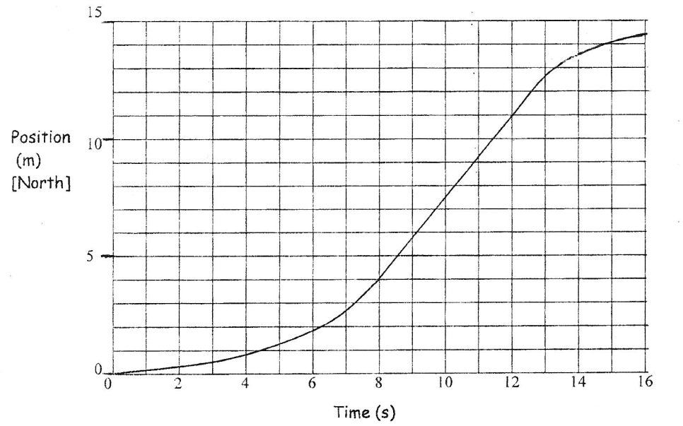a) The graph below is a ______________________________________ graph showing the motion of a toy car.

Find the instantaneous velocity at:

a) 6.0 s:

b) 10.0 s:

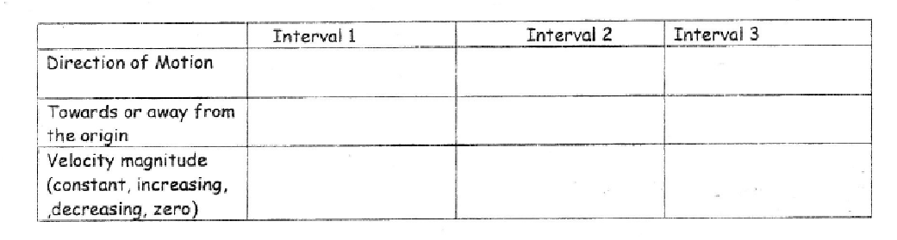

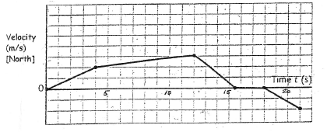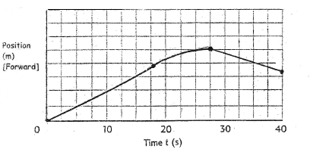b) The graph is a ____________________________ graph. c) The graph is a ________________________ graph.

|  |  |  |  |  |  |
| --- | --- | --- | --- | --- | --- |
| Interval | 1 | 2 | 3 | 4 | 5 |
| Direction of  of Motion |  |  |  |  |  |
| Speed Description |  |  |  |  |  |

|  |  |  |  |
| --- | --- | --- | --- |
| Interval | 1 | 2 | 3 |
| Direction of  of Motion |  |  |  |
| Moving towards or away from origin |  |  |  |
| Speed Description  (constant, speeding up, slowing down) |  |  |  |

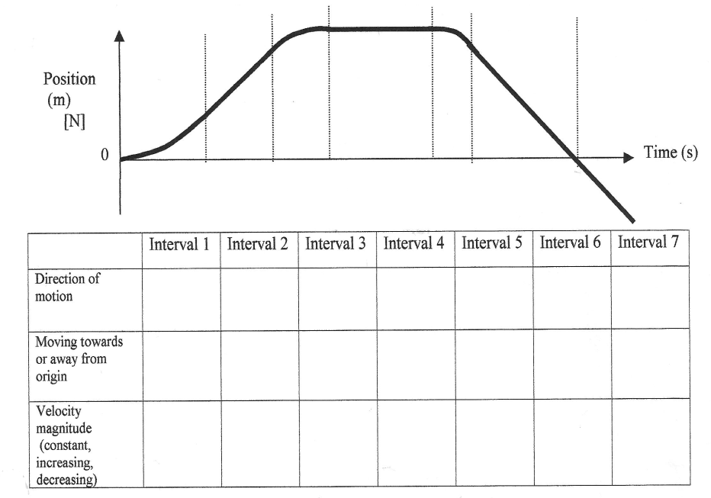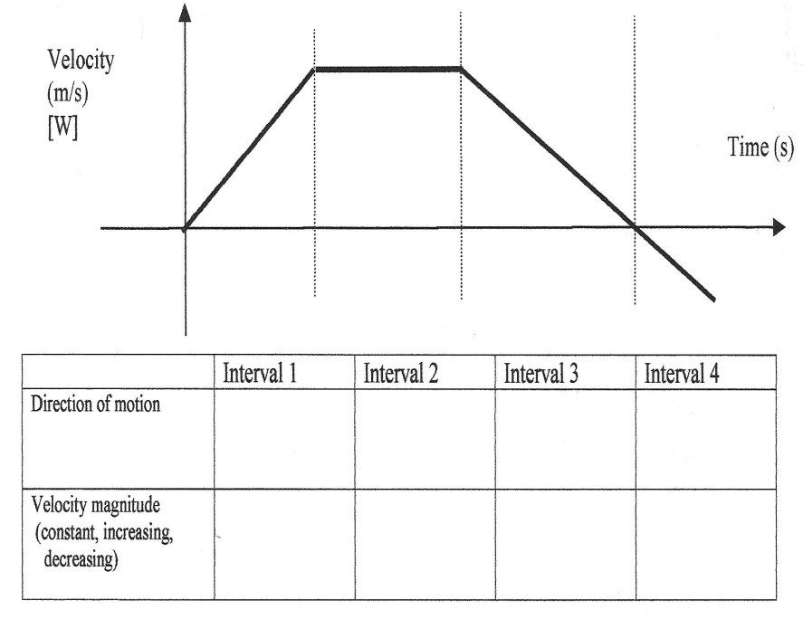d) The graph is a ____________________________ graph. e) The graph is a ________________________ graph

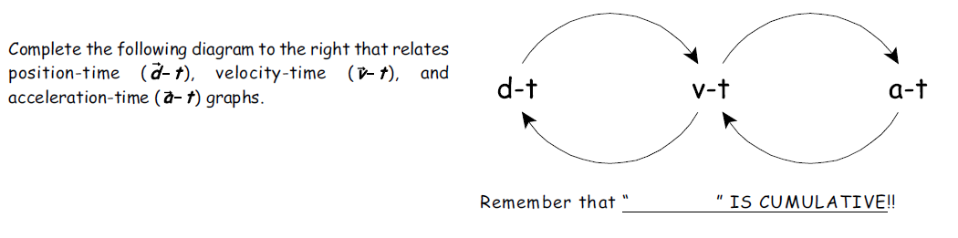

2. **Moving Between Graphs**

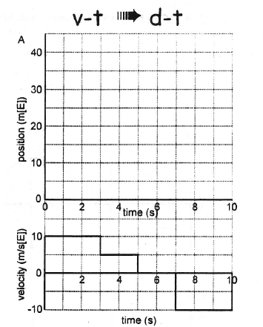**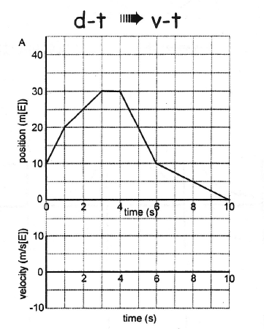Draw the missing graph:**

**a) b)**

*Assumethe object starts at **(0,0).**

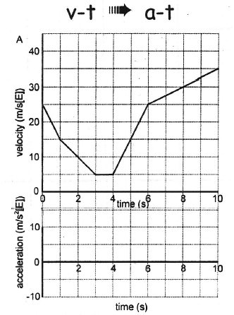**2. Continued Calculations:**

**c)**

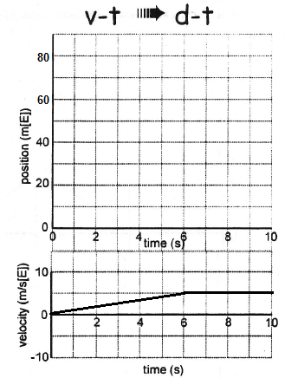

**d)** **Assume the object starts 10.0 m E of origin at**

**time zero.**

**3. Generate the d-t and a-t graphs for each of the given v-t graph below. For the position-time graph plot,**

**assume that the object starts at the origin at time zero (0,0).**

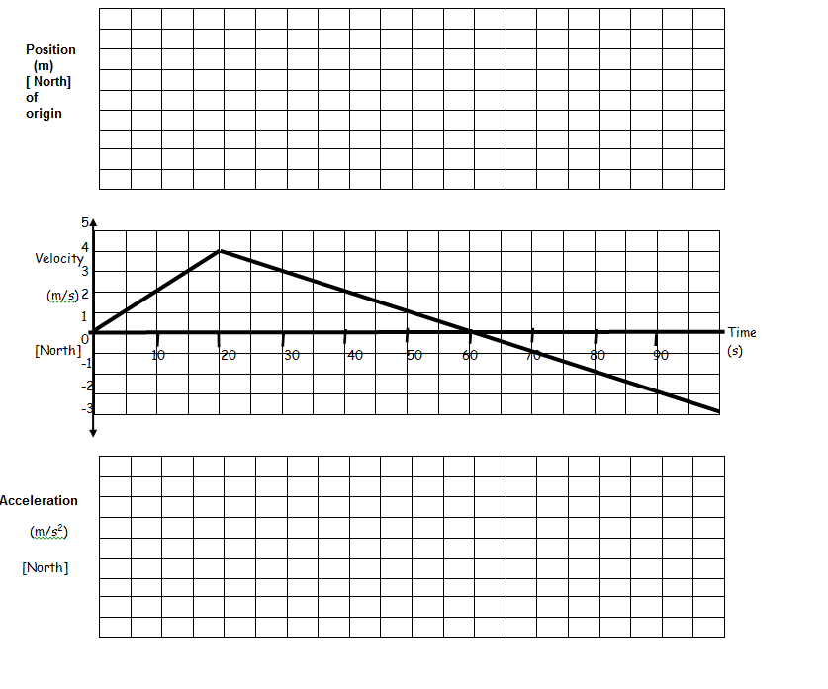

**Calculations:**

v-t to a-t: v-t to d-t: (* Include a t-chart!!)

**Describe the motion of the object:**

**Interval 1:**

**Interval 2:**

**Interval 3:**